USER GUIDE
BRS Memberships

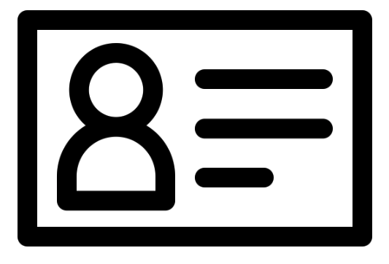

TABLE OF CONTENTS

INTRODUCTION 3
GENERAL NAVIGATION AND SYSTEM OVERVIEW 4
SYSTEM SETTINGS 7
General 7
Tax Settings 8
Subscription Cycles 9
Payment Schemes 9
Payment Types 10
Membership Statuses 11
Note Types 11
Wallets 12
Bill Templates 13
Email Templates 13
Member Filters 14
MEMBERSHIP TYPES & CHAINING MEMBERSHIPS 15
Creating Membership Types 15
Chaining Membership Types 16
MEMBERS 17
Adding Member Data 17
Amending Member Data 18
SUBSCRIPTIONS 18
Creating Subscriptions 18
Applying Subscriptions 19
Editing Subscriptions 22
Removing Subscriptions 23
BILLING 24
Creating a Bill 24
Publishing a Bill Batch 28
Publishing a Single Bill 31
Resending a Bill Batch 31
What do Bills look like 33
Editing a Bill 34
Cancelling/Deleting a Bill 35
APPLYING A PAYMENT SCHEME 36
PAYMENTS 37
Adding a Manual Payment 38
Viewing Payments 42
Refunding Payments 41
Cancelling future Scheduled Payments 43
ONLINE PAYMENTS REPORTING 44
REPORTING SUITE 45
DATA TABLE REPORTING 48
BRS MEMBERSHIPS – FUNCTIONALITY FOR MEMBERS 49
Browser Version 49
Members Booking App
............................................................................................................. 50

BRS MEMBERSHIPS

What is BRS Memberships?
BRS Memberships is a membership management platform, developed by BRSGolf and GOLFNOW allowing you to administer your member database, manage member subscriptions, send out bills and manage payments online.
BRS Memberships integrates seamlessly into your existing BRS Golf system, meaning you can manage your timesheet, online booking and membership management all from within a single platform.
This documentation will guide a user through the process of getting BRS Memberships set up and ready to use, as well as covering the main processes involved in managing subscriptions and bills through the Memberships module and general functionality.

GENERAL NAVIGATION AND SYSTEM OVERVIEW

General Navigation
When a user first navigates to the Memberships module from within BRS, they are brought to the Dashboard. The Dashboard displays information regarding billing and payments and allows quick and easy access to the different areas of BRS Memberships.
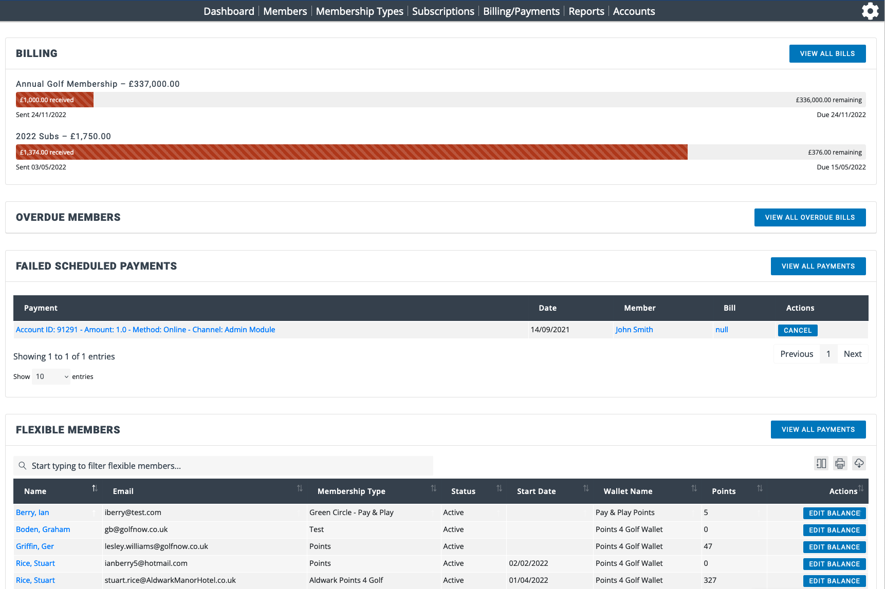
Navigation
Use the menu at the top of the Memberships system to access each area.
- Dashboard - Displays an overview of published bills, overdue members, a breakdown of member data and a list of unbilled subscriptions.
- Members - Member data can be added, deleted, viewed or exported.
- Membership Types - Manage membership types.
- Subscriptions - Subscriptions can be created and applied to members.
- Billing / Payments - Manage and process bills and payments.
- Reports - Access the BRS Memberships reporting suite.
- Accounts – Display and manage wallet balances en-masse.
There is a ‘gear’ icon () in the top right of the Memberships interface which will take a user to the system settings.

GENERAL NAVIGATION AND SYSTEM OVERVIEW

Online Payments
BRS Memberships uses our online payments solution, known simply as ‘Payments’, to handle online payments.
If your club does not already use our online Payments solution, some setup will be required to create your ‘Payments’ account. This will allow your members to pay for bills and wallet top-ups online. It also allows your administrative users to take payments through the system for individual members.
The Payments platform developed by BRS is designed specifically for golf clubs and ties into many other aspects of your BRS system. Visitor green fees booked through BRS will be pre-paid online, along with entries into Open Competitions. When paired with our Competition Purse module it can be used to manage Member Competition Payments. Payments also unlocks ‘Virtual Terminal’ and ‘Pay-by-link’ functionality, the latter being a great tool for taking payments for societies or visiting parties.
If you have not yet completed the set-up of your Payments account, please contact our support team on support@brsgolf.com or your BRS Memberships onboarding contact to arrange this.

SYSTEM SETTINGS

Settings
This section will outline the different parts of BRS Memberships which need to be set-up in order to use the BRS Memberships system effectively. To start, navigate to the Memberships area in BRS, then click the Settings icon (highlighted below) in the top right to access the system Settings.
- General
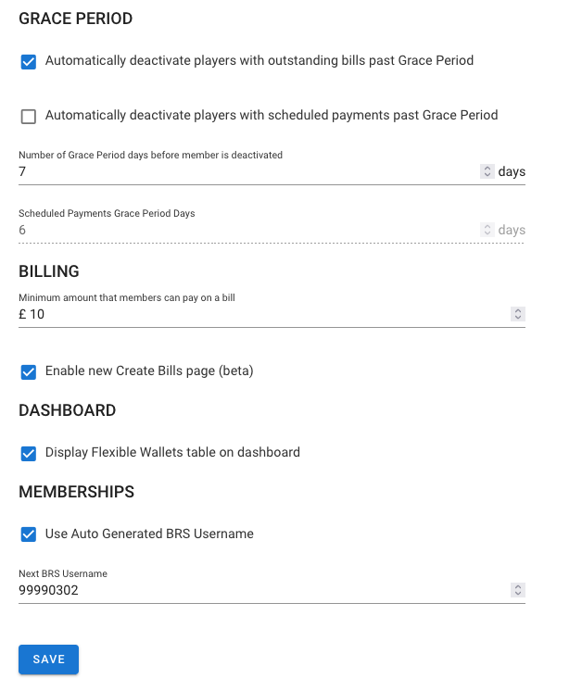
Grace Period - allows the golf club to define how to treat outstanding bills. This will only affect subscriptions which have been set as ‘Memberships’ subscription type.
- Automatically deactivate players with outstanding bills past Grace Period - tick this box if you want members to be automatically disabled once the grace period has expired, meaning they will no longer be able to log in to BRS.
- Number of grace periods days before member is deactivated - set the number of days a bill can be overdue before the member is disabled on BRS, preventing them from logging in or being booked on a tee time by other members.
Automatically deactivate players with scheduled payments past Grace Period - tick this box if you want members to be automatically disabled if any of their scheduled payment have failed once the scheduled payments grace period has expired, meaning they will no longer be able to log in to BRS.

SYSTEM SETTINGS
Settings, continued
- Scheduled Payments Grace Period days - set the number of days a scheduled payment can be overdue before the member is disabled on BRS, preventing them from logging in or being booked on a tee time by other members. Note that the minimum number of days you can set is 6 because the system will retry failed scheduled payments each day for 5 consecutive days.
Minimum amount that members can pay on a bill - set the minimum accepted amount of payment against a bill.
Display Flexible Wallets table on dashboard – if Flex Membership is enabled for your club this will be ticked.
Use Auto Generated BRS Username – tick this if you want the system to automatically assign the next number in the sequence. You must input the highest number currently in use.
- Tax Settings
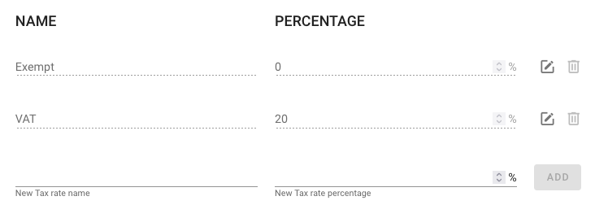
When creating a subscription that members can be billed for, you must set the tax rate for that item. Create different tax rates here.
- Complete the name and percentage.
You can have multiple tax rates set up as necessary and each subscription can have its own tax rate. The standard tax rate for your country will have been setup for you.

SYSTEM SETTINGS

Settings, continued
- Subscription Cycles
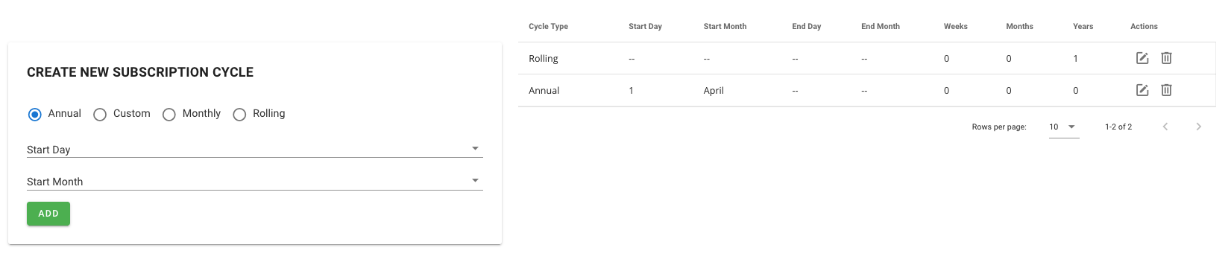
Any subscription in the system must be assigned a Subscription Cycle which is created here. You can add subscription cycles which are Annual, Custom, Monthly or Rolling. You can have one or many subscription cycles as you need.
- Set the cycle type and time range of the subscription cycle.
  - Annual – for subscription items that renew on the same date each year
  - Custom – for non-standard cycles where you can specify the start day and month and end day and month.
  - Monthly – subscription items that renew on a monthly basis.
  - Rolling – for non-standard cycles where you can specific the number of weeks, months and years e.g. 15 months. For clubs that offer membership that renews on the month the member joins, use Rolling for 1 year.

- Payment Schemes
When billing members, you may want to allow them to pay using an optional flexible payment plan and split the payment monthly, quarterly etc. You can create payment schemes that spread payments out across 12 monthly installments, or you can create a custom scheme. A fixed fee or % surcharge can be applied to each payment scheme. Note: in the UK, your club must be FCA approved to charge a fee or a % surcharge for payment schemes.
The distribution must equal 100% across the 12 months, however not every month needs to have a value set. You can customise a range of different payment plans as you see fit. Setting zero for a given month will skip that month.
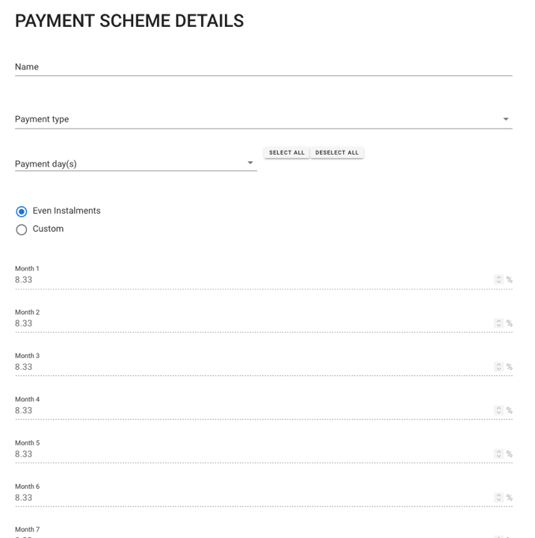
Click on Create Payment Scheme and complete the relevant fields:
- Name
- Payment type – which must be Online.
- Payment Days – select one or more dates the member can choose from for payments to be taken.
- Installment type - Even or Custom
  - Even installments - splits the total bill into even amounts every month across the payment period.
  - Custom allows you to define the percentage to be paid in each month of the cycle. Using this you can have the majority of the bill paid before the playing season starts or you can use it to avoid heavy financial periods e.g. Christmas.
- Surcharge type - No Charge or Fixed Fee.
One or more payment schemes are applied to Bills, offering members flexible ways to pay. When a member chooses to pay with an available payment scheme, they will choose the day of the month on which their recurring payment will be debited from their account at 01:00am.

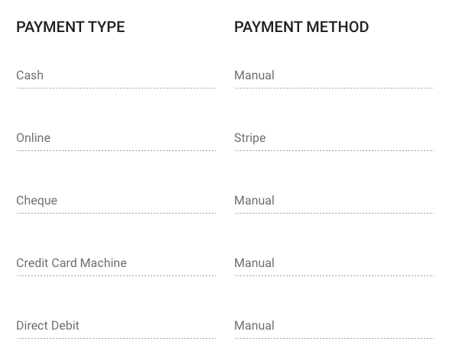
Payment Types
Add payment types that the club wish to support. ‘Stripe’ indicates the online payments platform that is used with BRS Memberships and cannot be removed.

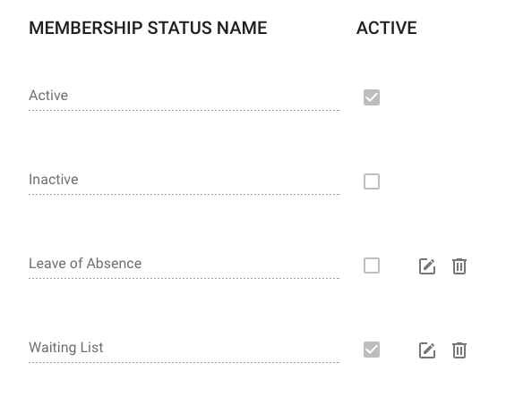
- Membership Statuses
Add the various membership statuses that you would like to be available in the system. Examples of these would be Active / Inactive / Leave of Absence etc. This could be useful for something like managing a waiting list.

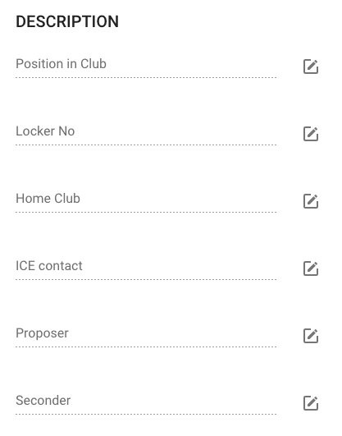
- Note Types
Add note types that you would like to be able to add to members’ records e.g. locker number, position in club etc. You can then record a note against a member’s record categorised with these note types.

SYSTEM SETTINGS

Settings, continued
- Wallets
BRS Memberships supports the ability to create multiple types of wallets which can be assigned to members. Currently Memberships only supports Points Wallets for Flex Membership and there is no ability to automatically take payment from any other wallet. However, some clubs are using wallets to allow members to save towards their annual bill.
Note: If your club uses BRS ePos then payment can be taken from a wallet at the tills.
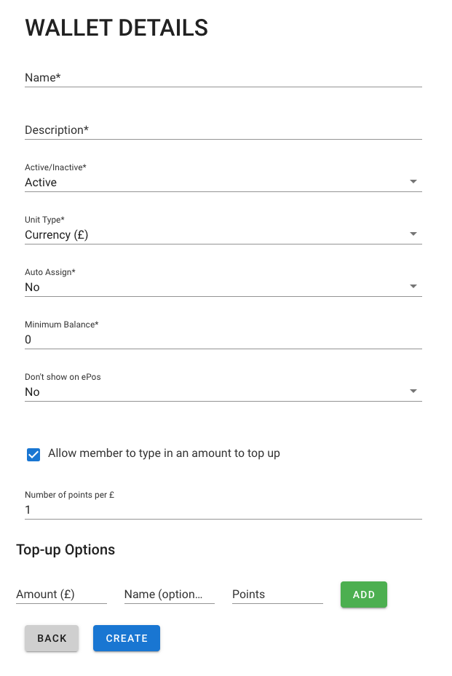
Click on Create Wallet and complete the relevant fields:
- Name
- Description
- Active/Inactive
- Unit Type - Currency or Points. Points wallets are used for Flexible Membership types.
- Auto Assign – is only valid for Points type wallets. When set to Yes, this wallet will be automatically assigned to any new member that has a Flexible Membership type.
- Minimum Balance - Set a negative value to allow a member to be overdrawn or set to zero to prevent someone from overdrawing or a positive amount to ensure a member keeps a minimum balance in their wallet.
- Don’t show on ePos – is only valid for clubs using BRS ePos. Setting this to Yes prevents this wallet from being used at the tills.
- Allow member to type in an amount to top up - tick the box to enable this.
- Member Top-Up Options - this applies to Flexible members topping up points wallets.
- Top-up Options - Set a monetary cost, name (optional) and quantity of points to be added.
Click Create to add the wallet.
Once create a wallet must be assigned to members before they can top it up. To assign to multiple members click Bulk Assign where one or more wallets can be assigned to one or more members or all members in selected membership types.
A User Guide for Flex Membership is available on request.

SYSTEM SETTINGS
Settings, continued
- Bill Templates
BRS Memberships has a default template for bills. You can use this Bill Templates feature to create your own template or have multiple templates for different membership types.
The easiest way to use this is to copy or amend an existing template. Click on the pencil icon to edit a template or the duplicate icon to create a new template, once duplicated you can edit the template to make changes and change the name.
You can include different fields in various places in the template and use the preview button to see what it looks like.
When you publish bills you can select the bill template you wish to use – we’ll see that later in this guide.
- Email Templates
BRS Memberships has a default template for emails. You can use this Email Templates feature to create your own template or have multiple templates for different membership types.
The easiest way to use this is to copy or amend an existing template. Click on the pencil icon to edit a template or the duplicate icon to create a new template, once duplicated you can edit the template to make changes and change the name.
You can include different fields in various places in the template and use the preview button to see what it looks like.
When you publish bills you can select the email template you wish to use – we’ll see that later in this guide.

SYSTEM SETTINGS

Settings, continued
- Member Filters
Member Filters give you a lot of flexibility to identify members with specific data i.e. a specific value in a Note Type.
Click Create Member Filter
- Description – describe the filter
- Subtitle – add more explanatory text
- Create a condition
  - Select the field you want to filter on
  - Select the qualifier - qualifiers will change depending on the field that you choose.
  - Input the value to filter on
  - Add further conditions to refine your filter and use the And/Or qualifier.
  - For example – filter Note Type equals Renewal Month AND Note Description equals November, will display a list of members who’s renewal month is November.
- You can group conditions together to make a rule.
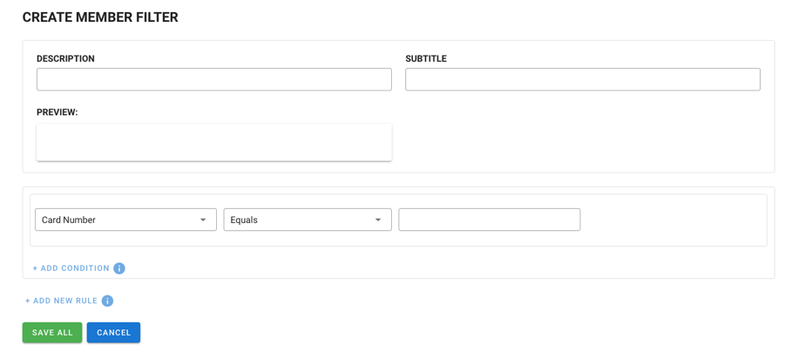
Once a filter has been created you can view the data by clicking on the magnifying glass icon, duplicate the filter, delete the filter or edit using the pencil icon. When you view the filtered data you can download it to Excel.
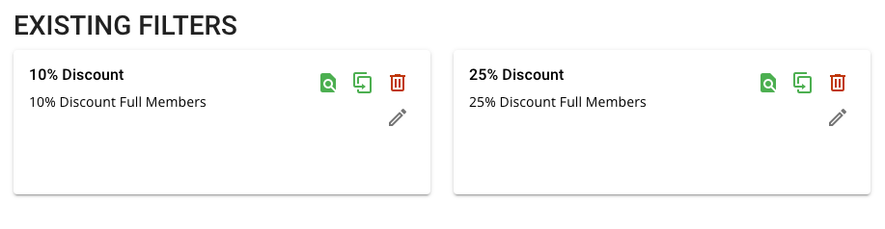
Member filters are used when Applying/Removing Subscriptions and Creating Bills and we’ll see this later in this guide.

MEMBERSHIP TYPES & CHAINING MEMBERSHIP

Creating Membership Types
The Membership Types that you have created in Tools – Membership Types have been synchronised to BRS Memberships. To view these, navigate to Memberships and Membership Types.
When setting up your membership types in BRS Memberships, you have the option to ‘chain’ membership types together. Chaining membership types means that when a member reaches the upper age limit of one category, they can be moved into the next category you have designated (pending approval). This will save on administration time and help reduce the number of members who are incorrectly billed.
Membership types can also have a minimum necessary length of service required to be in that membership type.
Follow the below steps to add a membership type:
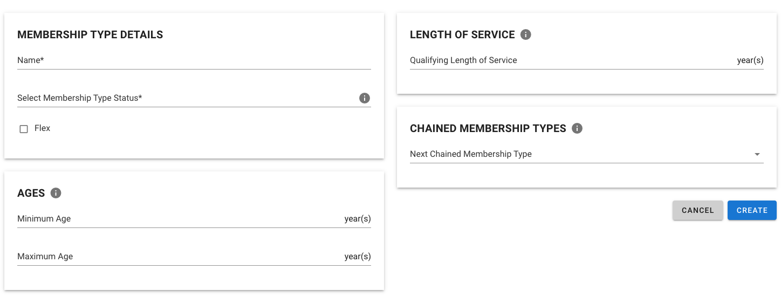
- Navigate to Memberships, then Membership Types.
- Click on Create Membership Type.
- Complete the required fields:
  - Name
  - Status
  - Flex - Indicates if this is a flexible membership type.
  - Minimum Age (optional)
  - Maximum Age (optional)
  - Qualifying Length of Service (optional)
  - Next Chained Membership Type (optional)
Click Create.
The newly created Membership Type will be added to your tee sheet Tools – Memberships Types automatically.

MEMBERSHIP TYPES & CHAINING MEMBERSHIP

Chaining Membership Types
Chained memberships can be managed via Memberships > Membership Types and then clicking the ‘Membership Type Changes’ button. Pending category changes need to be processed and invalid changes must be reviewed.
In order to make use of this feature, member’s date of birth and date of joining must be populated.
You will see three tabs:
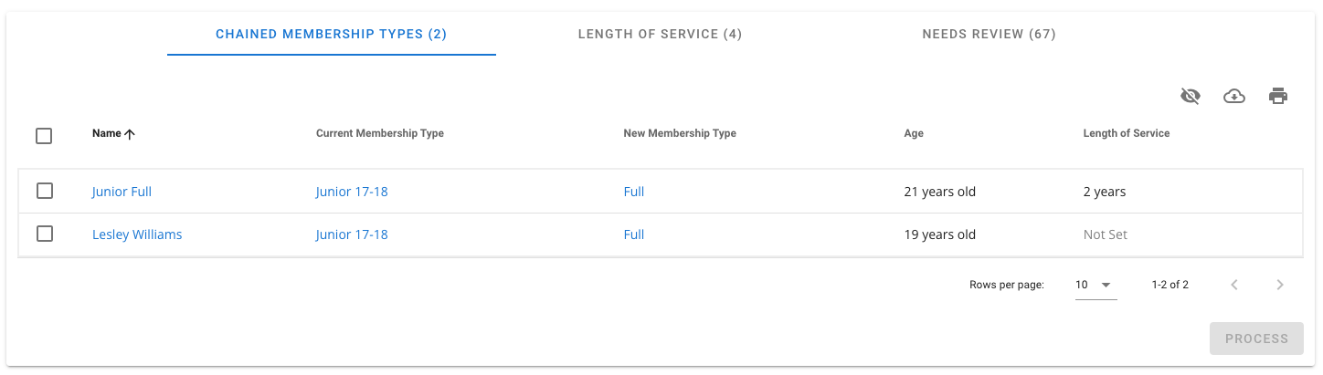
- Chained Membership Types
A list of members whose category is due to move from one chained membership type to the next, based on their date of birth. The table will show their current membership type as well as the category they will be moved to.
- Tick the box beside a member’s name and click Process.
- Click Confirm in the pop-up window to move the member into their new membership type.
- Length of Service
A list of members whose category is eligible to change, based on qualifying for a new category based on their length of service.
- Tick the box beside a member’s name and click Process.
- Click Confirm in the pop-up window to move the member into their new membership type.
- Needs Review
A list of members who are in a category for which they do not meet the criteria.
- The system will show the reason why a member needs to be reviewed, i.e. they are too young for their current membership type.
- Click on a member’s name to view their account. Edit the member’s account as necessary to resolve the inconsistency.

MEMBERS

Adding Member Data
Individual member records can be manually added by navigating to the Members option from the top navigation bar. Next, click the ‘Create Member’ button. You will need to populate the following fields (Mandatory fields are marked with an asterisk):

- Personal Information
  - First name*
  - Last name*
  - Gender*
  - Date of birth
- Address
  - Address line 1
  - Address line 2
  - Town / City
  - County
  - Postcode
  - Country

- Contact Details
  - Email address*
  - Phone Number
  - Mobile Number
  - Billing Type*
- Membership Details
  - Membership Type*
  - Card Number
  - Membership Status
  - CDH Number
  - Membership Join Date
  - Membership End Date
  - BRS Username

Click ‘Save’ to create a member record when you are happy with the details. The member details are automatically added to BRS Users, provided all the relevant information has been completed.

MEMBERS
Amending Member Data
To amend an existing member’s record, follow the below steps:
- Navigate to the Members area of BRS Memberships.
- Type the name, email, or membership number in the search bar to locate the member.
- Click the Edit icon () on the right to edit the member in the list.
- Update any necessary fields.
- Click Update at the bottom of the page.
If you are already viewing a member’s account and wish to amend any of their personal or contact information, you can use the Edit Member button highlighted below.

You can use the tabs in a member’s account page to navigate quickly between their Subscriptions, Account Balances, Billing information, Notes, and an Audit Log containing a history of all changes made to the account.

SUBSCRIPTIONS
Creating Subscriptions
Subscriptions are the recurring fees associated with being a member of the golf club. These would typically include items like Annual Membership fees, Locker fees, Insurance etc. Subscription items must be created individually and can then be applied to one or more members. After Subscriptions are applied to members, a bill can be sent for these fees. To create Subscriptions, click on Subscriptions from the navigation bar of BRS Memberships and click Create New Subscription. Fill in the following fields:
- Subscription Details
  - Subscription Name
  - Subscription Type
    - ‘Memberships’ is used to group subscription items that relate to club membership e.g. annual subscription.
    - ‘Fee’ is to group all subscription items that are fees e.g. locker fee, insurance.
    - ‘Account’ is not currently available.
  - GL Code – general ledger code.
  - Subscription Status
- Pricing
  - Pricing Method - Fixed or Priced by Membership Type. Note: when pricing by membership type make sure you untick any that are not included or are left as 0.00.
- Additional Details
  - Tax Rate
  - Pro-ratable - Select this if the subscription item can be pro-rated on bills, based on a count of the number of days remaining in the subscription year.
  - Renews Automatically - Check this box if you would like this subscription to automatically renew at the end of the subscription period, meaning you will not need to re-apply the subscription at the end of its subscription cycle, and then choose the relevant subscription cycle.
When you are happy with the details you have entered, click Create Subscription.

SUBSCRIPTIONS
Applying Subscriptions
Subscriptions you have created MUST be applied to members before they bills can be created.
To apply subscriptions to members, navigate to BRS Memberships and click Subscriptions.
Click Apply / Remove Subscription, the next page will, by default, bring you to Apply Subscription and complete these fields:

- Choose each subscription you want to apply - you can use the search bar to filter the list of subscriptions. You may apply multiple subscriptions at the same time.
- For each subscription item you may need to select the start date for the subscription or the start of the cycle using a form similar to this:
  - Select the start date OR if the subscription is linked to a cycle select the cycle start month and year.
    - If pro-rating, select the start date the system will use to calculate the pro-rated amount.
  - Choose what action to take after the subscription expires:
    - No further action.
    - Subscription renews automatically.
    - Automatically apply a different subscription.
      - If you choose to apply a different subscription, set whether the new subscription will automatically renew when it expires.
  - Click Apply.
- Select whether you wish to apply the subscription(s) to selected membership types, selected members, or a custom filter.
  - You can select one or more membership types. You can use the filter to search for specific membership types
  - You can select one or more members and as with membership types, you can use the filter to search for specific members
  - For Custom Filters, you can single a single filter to use or create a new filter. This is ideal to use for members with specific note types e.g. apply the Locker Fee subscription item to all members with a locker note type.
- Click Preview to view a summary of the changes which this action will apply.
SUBSCRIPTIONS
Applying Subscriptions, continued

- A pop-up will summarise the operation. When you are happy with the changes being made, click Confirm. If you are unsure, click outside the pop-up to close it without making changes.

- The system will flag up issues for review, for example, when there is no price for their membership type actually set up for that subscription or if a member already has that subscription item applied.

SUBSCRIPTIONS
Editing Subscriptions
To edit an existing subscription, navigate to Memberships in BRS and then go to Subscriptions to view a table of your subscriptions. There are two ways to begin editing a subscription, either:
- Click the Edit icon ()in the actions column on the right of the table of subscriptions.
OR
- Click on the name of the subscription to view the details of the subscription, then click the Update Subscription button at the bottom of the page.
You will be brought to the Edit Subscription page allowing you to amend the subscription details.
- Make the necessary changes to the subscription.
  - Note: if a subscription item has been applied to one or more members, you will not be able to change the Renews Automatically setting. You will be able to change the prices.
- Click Update to save the amendments.
- If the price has changed, any NEW bills will pick up the new price.
  - Note: existing bills which include this subscription will retain the old price, even if it is for the future. You must edit any existing bills if you wish them to reflect the new price.
When viewing the table of all your subscriptions, you may see a Delete icon (). The Delete icon will be disabled if the subscription has been applied to one or more members.

SUBSCRIPTIONS
Removing Subscriptions
The process to remove a subscription is much the same as the process of applying subscriptions. Navigate to Memberships and click Subscriptions.
- Click Apply / Remove Subscription:
  - Click on the Remove Subscription tab.
  - Choose each subscription you want to remove - you can use the search bar to filter the list of subscriptions.
  - Pick the relevant subscription cycle.
  - Linked Subscriptions - If any subscriptions are linked to the one being removed (e.g. the selected subscription was going to apply another subscription after it expired) then you can remove these linked subscriptions as well.
  - Click Remove.
- Select whether you wish to remove the subscription(s) from selected membership types, or selected members, or a custom filter. Then you can select the individual membership types, members, or filter.
- Click Preview to view a summary of the changes which this action will apply.
- When you are happy with the changes being made, click Confirm.
Please note, a subscription which is linked to an active bill cannot be removed. The bill in question must be edited, or cancelled, before the subscription can be removed from a member or membership type.

Creating a Bill
BILLING
Creating a Bill will allow you to collect payment for members’ subscriptions. Bills can be created for a single member, a group of membership types or all members. Navigate to BRS Memberships, click on Billing/Payments and click Create Bills. Creating bills for multiple members is called a Bill Batch.

This is the new Create Bills page and for a limited time you will have the ability to switch to the Old Billing page. This guide has been written to help you with the new Create Bills page only.
- Step 1 – Enter Billing Details
  - Billing Reference (name of the Bill).
  - Due Date - members can be automatically deactivated when the bill’s due date + grace period has passed. This is configured in the Settings area of Memberships.

- Step 2 – Select Bill Period / Who to Bill. Click Set Bill Filters
  - The first step is to select the cycle/period you wish to Bill. This will filter the subscriptions that you can choose in Step 3.

    - For All Cycles, input the date range to select subscriptions from.
    - For Selected Cycles, select the cycle type e.g. Annual, Rolling etc. You will then need to choose the date range or month/year depending on the cycle type.
Click Add Cycle/Period
Creating a Bill, continued
BILLING

    - Select No Cycles/Periods for subscriptions that aren’t linked to a cycle or if you wish to bill for custom line items only.
  - Click Next
  - The second step is to select Who to Bill

    - Select Bill all members to bill everyone. We do not recommend this option as the volume of data may be very large.
    - Select Bill selected members and use the search bar to search for and choose one or multiple members to be billed.
    - Select Bill selected membership types - use the search bar to search for membership types, choose one or multiple membership types to be billed.
    - Select Custom Filter and click Select Filter to use an existing Member Filter to bill those members. This would be very useful for members entitled to a discount on their subscription for example.
  - Click Save

BILLING
Creating a Bill, continued
- Step 3 Select Subscriptions, Discounts and Custom Items
  - The system may have filtered the list of subscription, depending on the cycle you selected previously.
  - Choose one or multiple Subscriptions from the list, using the search bar to filter if necessary.
  - Having selected a subscription you then have the option to apply a discount.
    - Select the discount type – Set Amount or Percentage
    - Set the amount
    - Set an expiry date – the discount will no longer apply if the bill is paid after this date.
    - Input any discount notes – this will appear on the members bill
    - NOTE: This discount will apply to every bill, with this subscription item, in this bill batch.
  - Add any Custom Bill Items
This section gives you the ability to bill members for the likes of one-off expenses such as billing a member for the costs of repairing a broken window, for example. Multiple custom items can be added to a bill. Note: adding a custom item to a bill batch, will add the item to every bill in the batch.
    - Set the description.
    - Choose the tax rate.
    - Enter a price.
    - Click Add Item.
    - NOTE: A negative value cannot be entered here.
- Step 4 Payment Scheme
NOTE: all bills support full one-off payment, even if a Payment Scheme is applied.

BILLING
Creating a Bill, continued
Click Preview and the system will show you how many members will be bill, how many subscription items, expected revenue etc.

Here you can click Pending changes to see a list of changes that will be made if you click Confirm. Similarly you can see a list of Unaffected Members from this change.
When you click Confirm, the bill/bill batch will be drafted and you have the option to:
- Select a file to attach to the bill email.
- Add a custom message.
- Select the Bill Template you wish to use.
- Select the Email Template you wish to use.
- Click the X in the top right to view the draft bill(s)

BILLING
Publishing a Bill Batch
When you save a bill, by default it is saved as a draft and can be published at a later time allowing you to spot check and make changes to a bill before sending it. When a bill is in a draft state it is not visible to members and payments cannot be taken against the bill. To publish a bill, follow the below steps.
- Navigate to the Billing / Payments area of BRS Memberships.
- Locate the bill batch you want to publish in the table of bills, using the filters at the top of the table if necessary.
- Click on the bill reference in the leftmost column to view the details of the bill.
- Click the Publish button.

- A pop-up will appear allowing you to
  - Select a file to attach to the bill email.
  - Add a custom message.
  - Select the Bill Template you wish to use.
  - Select the Email Template you wish to use

BILLING

Publishing a Bill Batch, continued
Any members whose preferred billing option is Email will receive an email with the bill PDF attached. Bills for members whose preferred billing method is post will be collated into a downloadable PDF which you can then print. To download the PDF:
- Go to the Billing / Payments area of the system.
- Find the relevant bill batch.
- Click on the bill reference to view the bill details page.
- You will see a link directly beneath the Publish Options button.
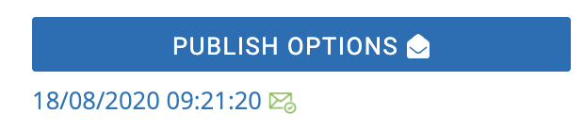
- Click this link to download the file and you can use your browser settings to print the bills.

BILLING

Publishing a Single Bill
Publishing a bill which is being sent to a single member varies slightly from publishing a batch bill. The bill is created in the same way, however when you save the draft, follow these steps:
- Navigate to the Billing / Payments area of BRS Memberships.
- Locate the individual bill you want to publish in the table of bills, using the filters at the top of the table if necessary.
  - By default, bills are grouped by reference. To search on all bills, including those within a bill batch, choose No Grouping and then input your search criteria.
- Click on the bill reference in the leftmost column to view the details of the bill.
- You will see the below page which shows that the bill is in Draft and has not been previously published, as highlighted.
- Click the highlighted Publish button to publish this bill.
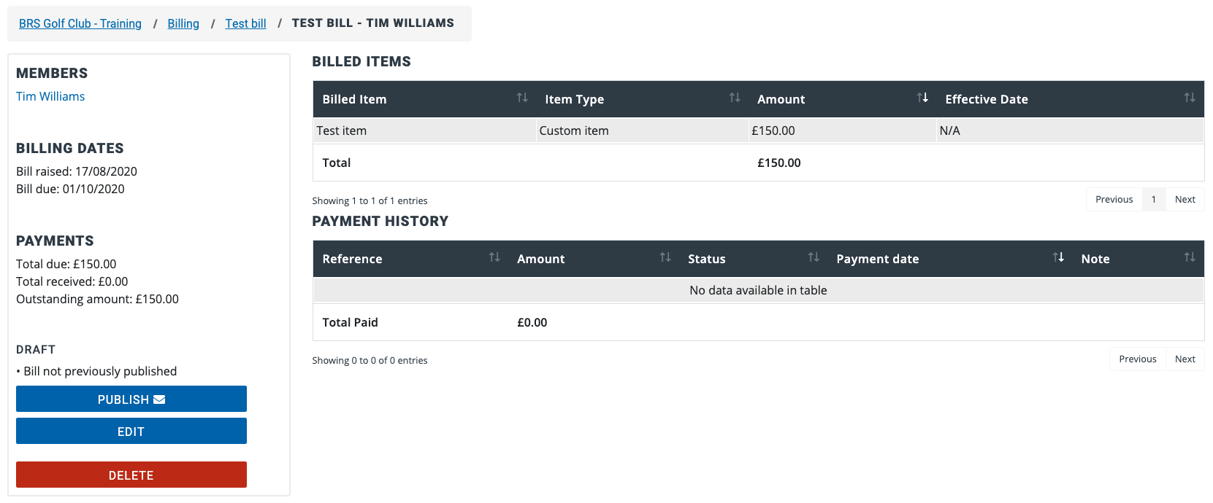
If this member’s preferred billing method is post, follow the steps outlined above to locate the bill again. In the same area highlighted in the above image, you will now see a link just above a Resend Bill button. Clicking on the link will download the bill and you can use your browser settings to print the bill.
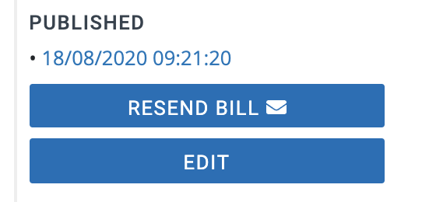
Clicking the Resend Bill button will resend the bill by email if the member’s chosen billing method is email.

BILLING

Resending a Bill Batch
After a bill has been published you may need to resend it to a specific member, all members, or all members yet to pay the bill.
For a published bill batch you wish to resend, follow these steps to locate the bill:
- Navigate to the Billing / Payments area of BRS Memberships.
- Locate the bill batch you want to resend in the table of bills, using the filters at the top of the table if necessary.
- Click on the bill reference in the leftmost column to view the details of the bill.
- On the bill batch page, click the Publish Options button in the top right.
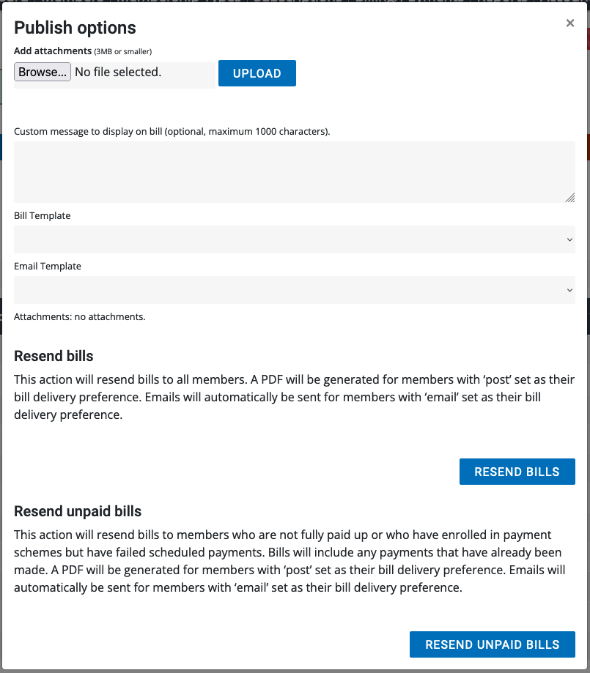
- A pop-up will appear allowing you to:
  - Select a file to attach to the bill email.
  - Add a custom message.
  - Select the Bill Template you wish to use.
  - Select the Email Template you wish to use.

BILLING

Resending a Bill Batch, continued
- Then you have 2 options:
- Resend Bills
This will resend bills to everyone in the bill batch. A PDF will be generated for members with ‘post’ set as their bill delivery preference. Emails will automatically be sent for members with ‘email’ set as their bill delivery preference.
- Resend Unpaid Bills
This action will resend bills to members who are not fully paid up or who have enrolled in payment schemes but have failed scheduled payments. Bills will include any payments that have already been made. A PDF will be generated for members with ‘post’ set as their bill delivery preference. Emails will automatically be sent for members with ‘email’ set as their bill delivery preference.

BILLING

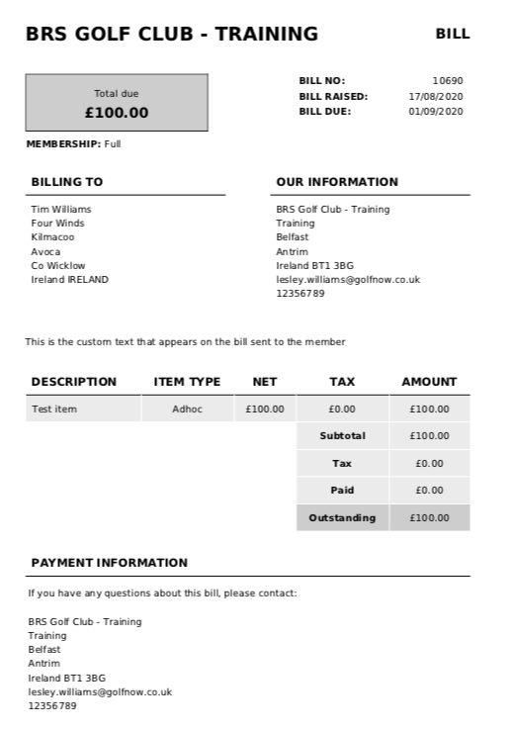
What do Bills look like?
The image to the right outlines what the default bill PDF looks like. However, the layout of the bill PDF depends on the bill template that you have chosen. Bill templates can be customised in the Settings.
Members with email addresses receive these via email. For members without email addresses, the bill PDFs can be downloaded and printed using your browser settings.
The bill outlines the total amount of the bill and breaks this down by each subscription / line item in the ‘Description’ area of the page.

BILLING

Editing a Bill
You can edit a bill you have created, even if it has been published. You may need to edit a bill to include another subscription item for a member or possibly add a custom bill line etc. To edit a bill:
- Navigate to the Billing / Payments area of BRS Memberships.
- Find the relevant bill in the table, using the filters to narrow your search if necessary.
  - If the bill is part of a bill batch, click on the Group by Batch option and then use the filter to narrow your search.
- Click on the bill in the Reference column to view the bill in more detail.
- Click Edit to amend any of the details of the bill like the due date, remove or add subscription items, remove or add payment schemes etc and click Save.
- After updating a bill, it should be published again by using the Resend Bill button in the below screenshot.
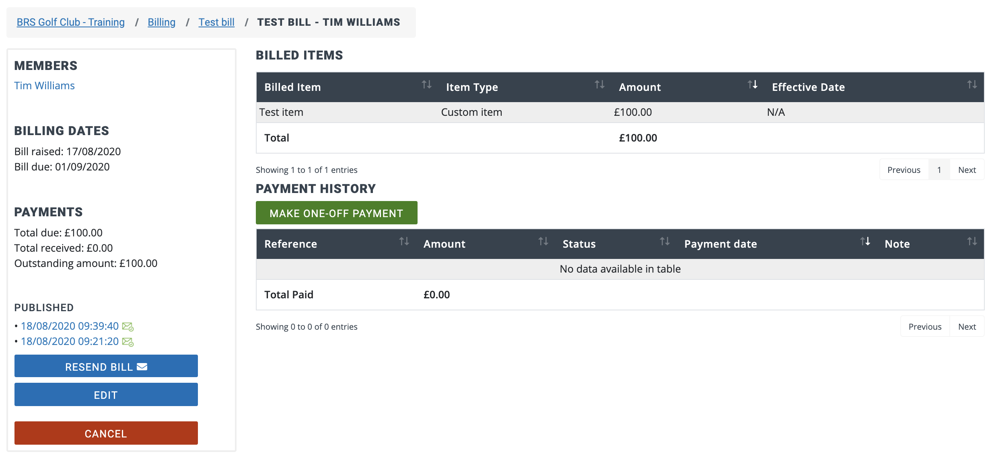
Every time the bill has been published is recorded and displayed above the Resend Bill and Edit buttons in the bottom left of the page.
You can edit a Bill Batch to change every bill in the batch, however, it is not possible to add or remove Payment Schemes from a bill batch, this would need to be done on individual bills within the batch. You can change the bill due date and add or remove subscriptions items.

BILLING

Cancelling / Deleting a Bill
In BRS memberships a draft bill/bill batch can be deleted, however a published bill can only be cancelled. Deleting a draft bill will completely remove it from the list of bills. A published bill which has been cancelled can still be viewed as there may have been payments made against a published bill.
On the Billing/Payments page you can click on the options icon () to either Cancel or Delete the bill. Published bills have the ‘Cancel Bill’ option enabled, whereas draft bills will have the Delete Bill enabled. For either Published or Draft bills you can apply a payment which is covered in the next section of this guide.
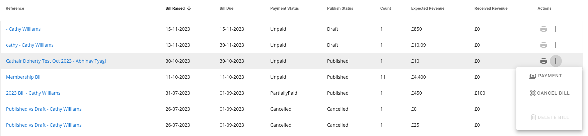
If you only need to remove a smaller number of bills, you can access the list of members included in the batch by clicking on the bill reference in the bills table or click on Group by Batch in the Billing page and use filter to search for a specific member to delete / cancel their bill.

APPLYING A PAYMENT SCHEME

Applying a Payment Scheme for a Member
You may want to allow members to pay a bill using an optional flexible payment plan and split the payment monthly, quarterly etc. When creating a bill, you can apply one or many payment schemes to that bill which your members can choose to use if they wish.
Payment schemes you add to a bill will be available for a member to choose through their member login. However, an admin user can apply a payment scheme on behalf of a member through the Memberships system when viewing the member’s unique bill. There are two ways to locate the bill:
- Viewing a bill through the Members section.
- Click on the Members option in the Memberships System.
- Use the search bar to find the relevant member and click on their name to view their profile.
- Choose the ‘Billing’ tab within this member’s profile.
- You will see a list of bills associated with this member. Click on the bill reference to view the member’s bill.
- Viewing a bill through the Billing / Payments area.
- Navigate to the Billing / Payments area of the system.
- Find the bill in the list, using the search bar if necessary.
- Click on the bill reference to view the bill in more detail.
- If it is a batch bill (i.e. more than one member has been included in the bill), click on No Grouping and then search for the specific member whose bill you want to view.
- Click on the bill reference in the left column to view the member’s unique bill.
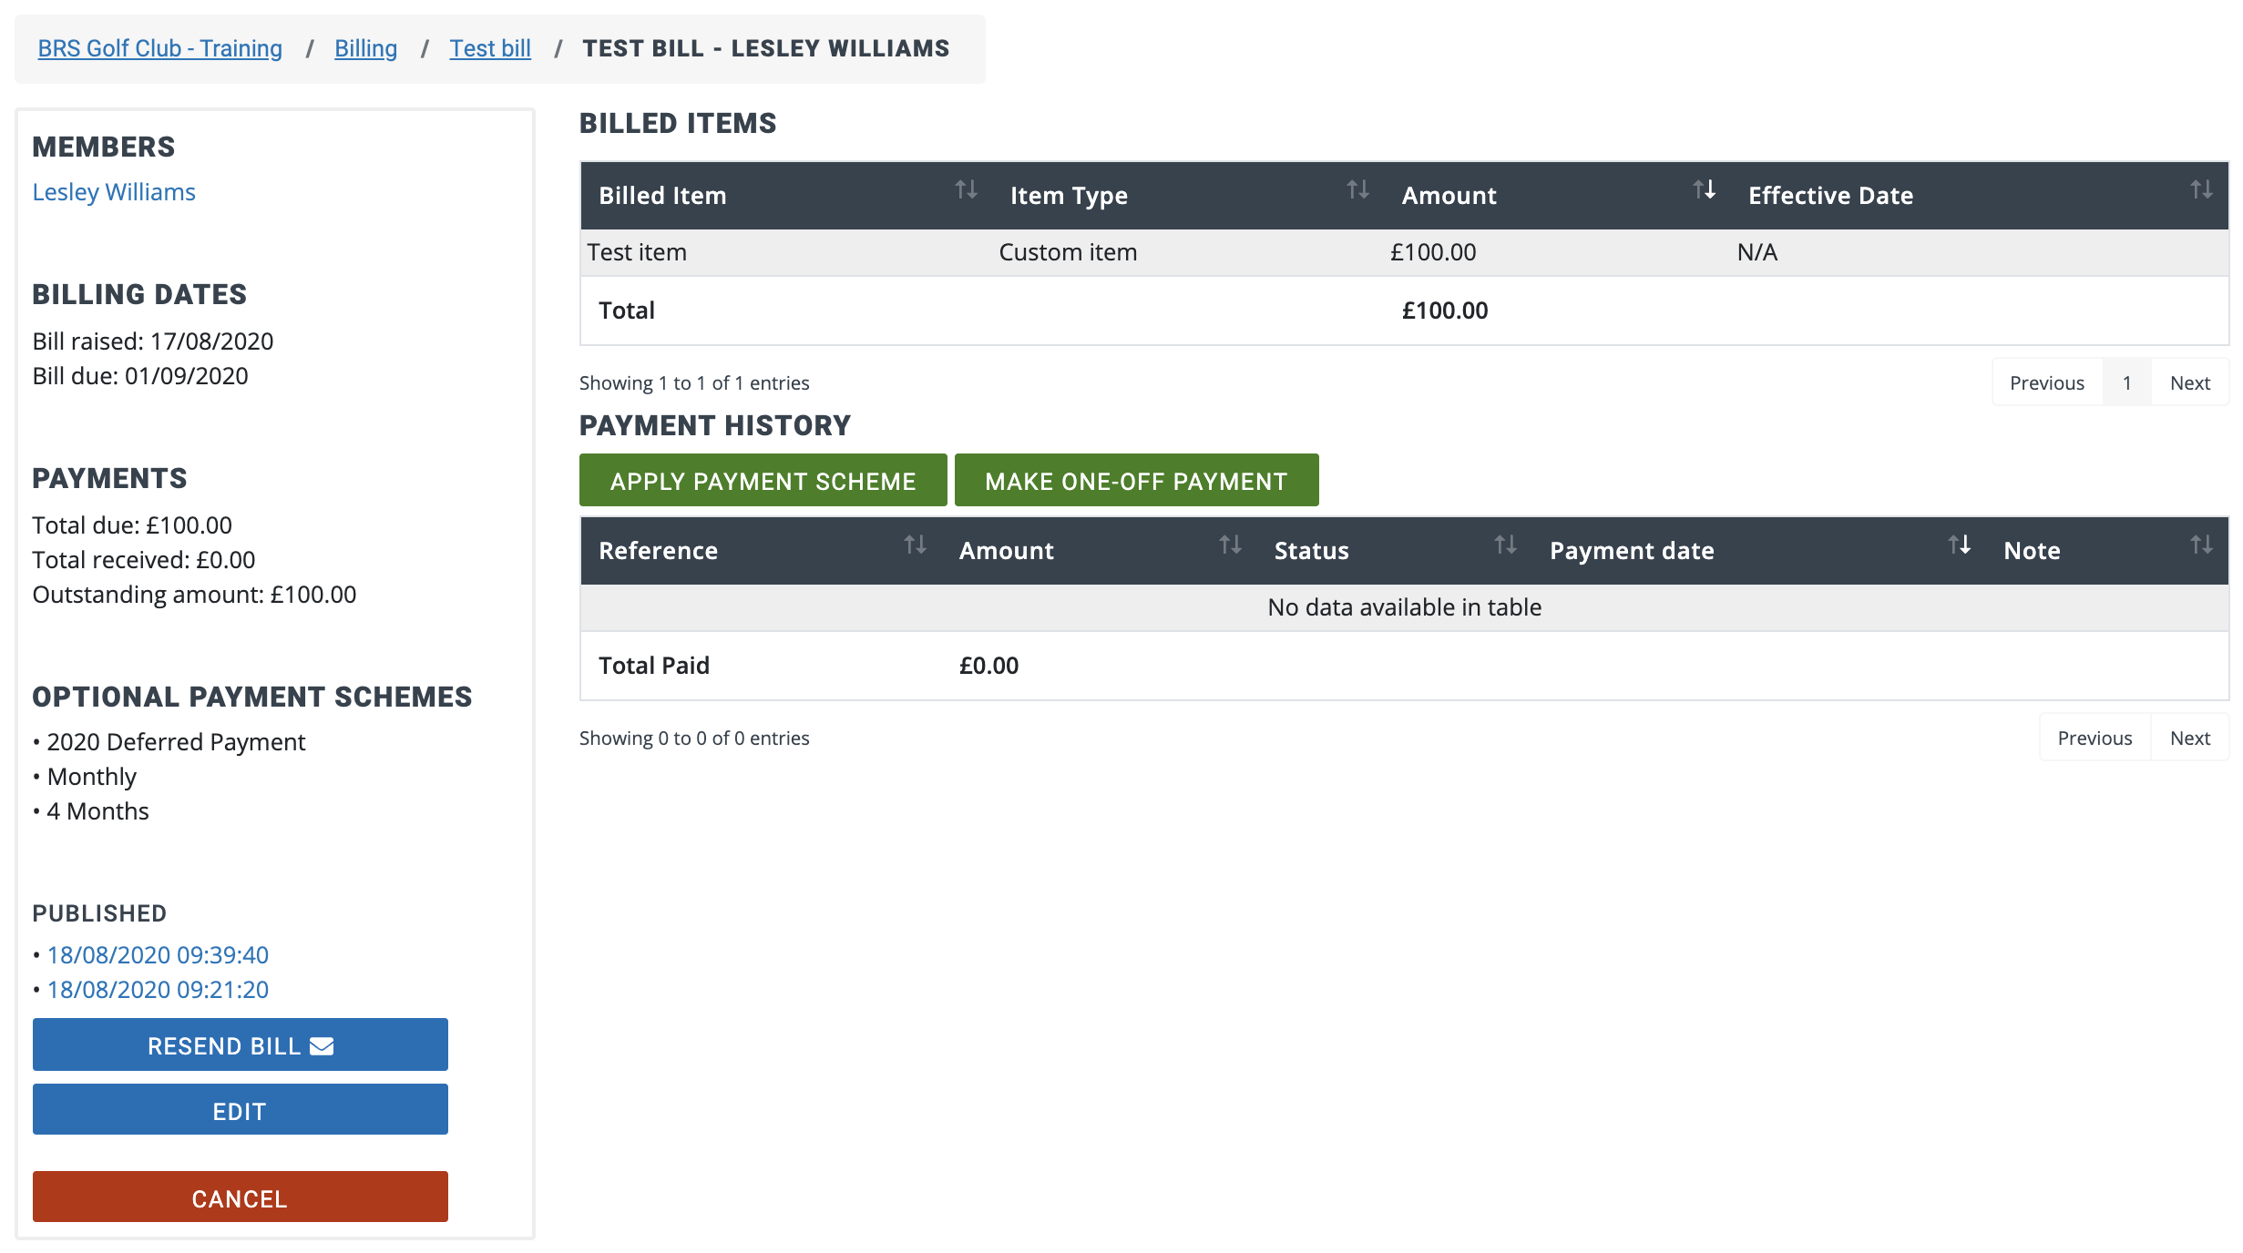
On the left you will see all available payment schemes for this bill. Click ‘Apply Payment Scheme’ to proceed to the next step.

APPLYING A PAYMENT SCHEME

Applying a Payment Scheme for a Member, continued
After clicking the ‘Apply Payment Scheme’ button.
- Select the Payment scheme to apply.
- Select the day of the month that payment will be taken.
  - If the day of the month is in the past, a warning message will display stating that the first payment will be taken today.
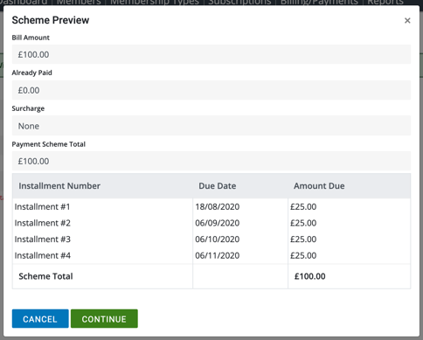
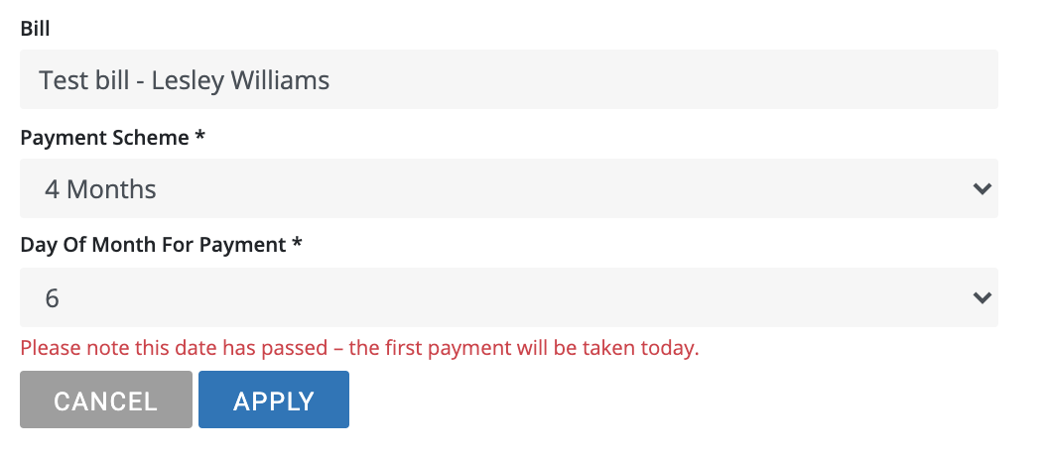
- Click Apply to see a preview of the scheme.

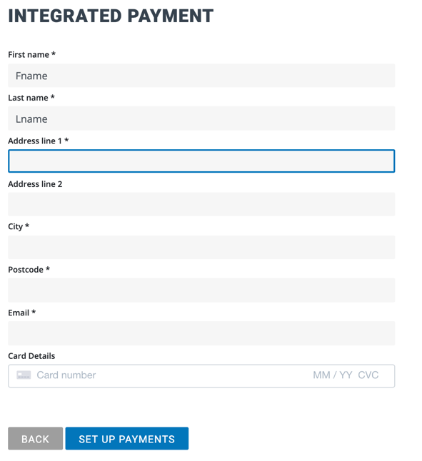
When you are happy with the details, click ‘Confirm’. If the member has card details on file, this card will automatically be used for the payment scheme. If the member does not have a card saved on file, you will need to enter their payment card details to set up this payment scheme using the Integrated Payment page the system will display.

Complete all the mandatory fields (marked with an *) and enter the member’s card number, expiry date and cvc and click ‘Set Up Payments’ to set up this payment scheme. In some cases, you may need to repeat the member’s postcode in the Card Details – this is a spot check as part of the Secure Customer Authentication scheme.

Note: If a member’s profile is set to Inactive their scheduled payments will NOT be sent to Stripe for processing.

PAYMENTS & ALLOCATIONS

Adding a Manual Payment
There are number of ways that an admin user can manually take or record a payment against a bill. In each method, after clicking the Make A Payment button, you will be prompted to confirm the amount of payment, and payment method.
- Member’s Profile
- Navigate to BRS Memberships and click on Members.
- Use the search bar to locate the necessary member.
- Click on the member’s name to view their profile.
- Choose the Billing tab (highlighted in the below image).
- Click the payment icon beside an outstanding bill to add a payment (highlighted below).
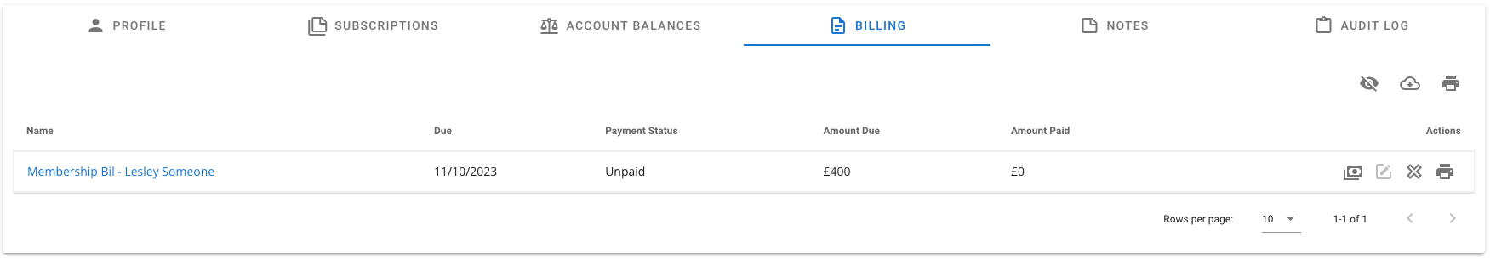
- Billing screen
- Go to the Billing / Payments area of BRS Memberships.
- Search for the bill using the search bar. Remember to deselect Group by Batch if the member’s bill is part of a Bill Batch.
- Click on the reference of the bill in question.
- Click the options icon and Payment to add a payment.
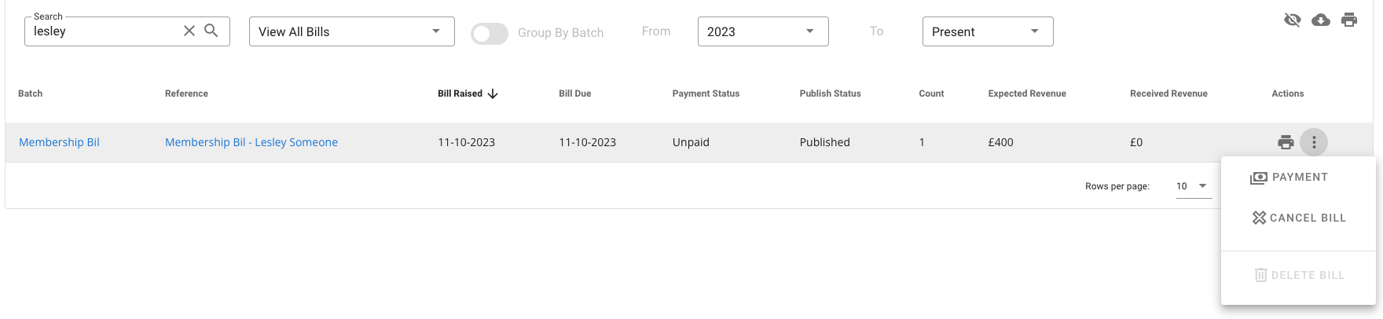

PAYMENTS & ALLOCATIONS

Adding a Manual Payment, continued
- Bill details
- Go to the Billing / Payments area of Memberships.
- Click on the reference of the bill in question in the table of bills.
- Search for the name of a specific member in the bill who you wish to take a payment for.
- Click on their unique bill reference in the left column to view their bill in more detail.
- Use the ‘Make One-Off Payment’ button to take a payment.
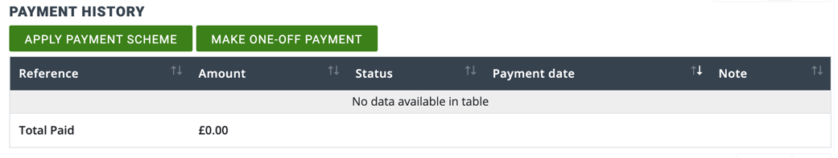
- Please note - this page is also where a member’s payment scheme can be managed by an admin user. A payment scheme can be applied or removed on behalf of the member.

The Make a Payment screen displays. There are 2 parts to this:
The first part is to input the payment amount, payment type and any notes. When done click Next.
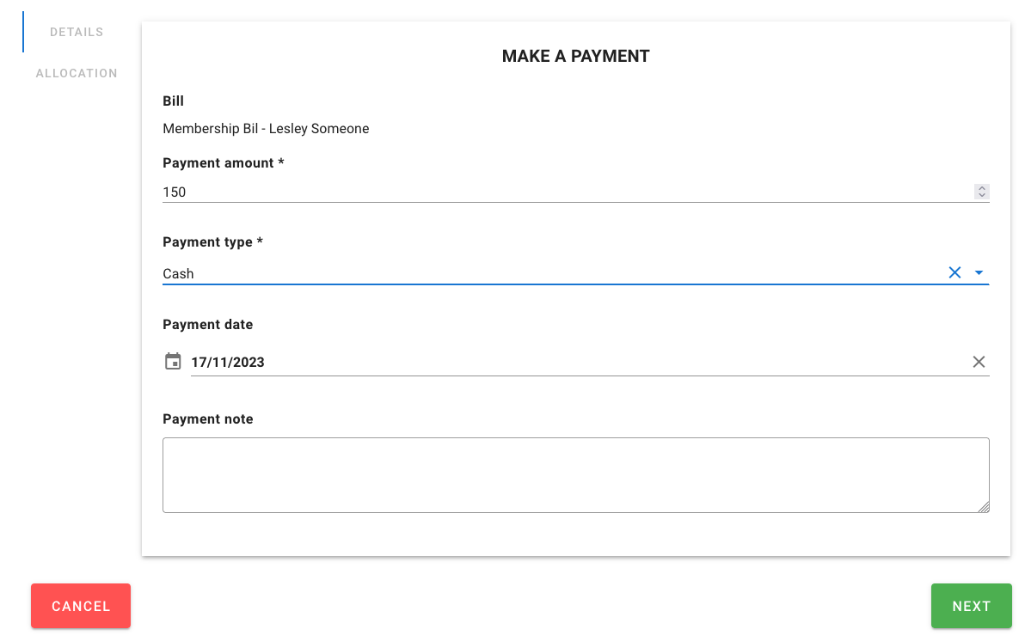
In all cases, if you choose ‘Online’ as the payment method, the next screen will display a virtual card terminal where the member’s billing address and payment card details must be entered. Complete all mandatory fields (marked with an *) and input the member’s card details. If the member has a card saved on file, it is not necessary to re-enter their card details.

PAYMENTS & ALLOCATIONS

Adding a Manual Payment, continued
The second part is to allocate payment to the subscription items. Where a bill has been part paid, this feature allows you to split the payment across each subscription item. In this example, the payment amount was £150 which is being split as £125 to the Membership subscription and £25 to the Golf Ireland Affiliation. Clicking on the pencil icon beside the subscription item allows you to change the amount to allocate, then click the Save icon.
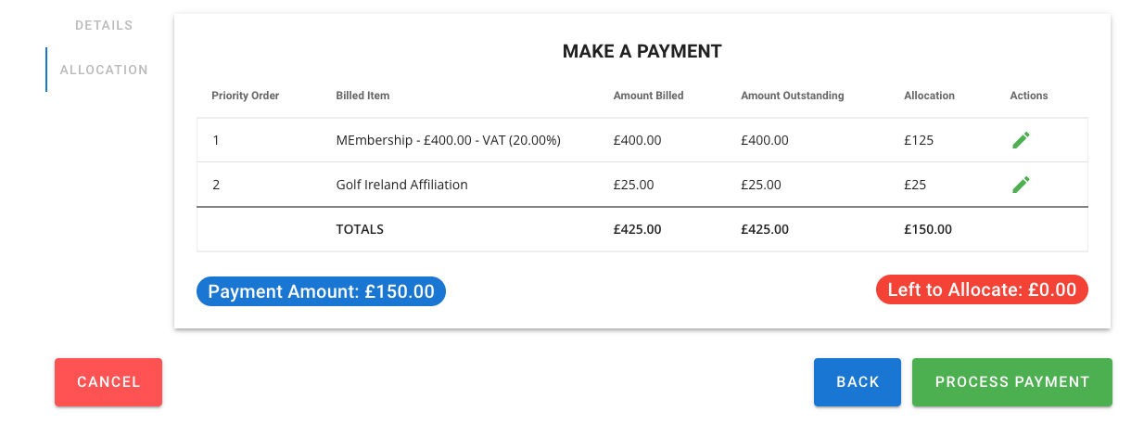
Once the Left to Allocate amount is 0.00 you can click Process Payment.
A receipt will automatically be sent to the member’s email address if they have one on file, if they do not have an email address, the receipt can be downloaded and printed through your browser settings. Payment references are automatically generated.

PAYMENTS & ALLOCATIONS

Viewing Payments
To view all payments that have been received for all bills, follow these steps:
- Navigate to BRS Memberships, then choose the Billing / Payments option.
- Click the ‘View All Payments’ button to see a list of all payments.
- You can search for a specific bill reference, member name, payment amount, payment type etc and/or choose a date range.
  - Click the Calendar All Time icon to choose or set a date range. Use the Custom Range option to specific the dates you want to view.
- The data can be exported in a spreadsheet by clicking the download icon ().
The data is divided into several columns:
- Payment Reference - this is automatically generated and provides some brief information on the payment.
  - Scheduled Payment is a payment that is linked to a Payment Scheme.
  - The ‘Channel’ will be included in the payment reference, either Member or Admin.
    - Admin - indicates that the payment was taken by one of the club’s administrative users.
    - Member - indicates that the member paid online through either the BRS Members site, or the BRS Members Booking App.
- Payment Date - the date on which the payment was made.
- Player Name - name of the member the payment relates to.
- Membership Type
- Bill Name - denotes the bill, (if any) that the payment has been made against.
- Payment Amount - the value of the specific payment.
- Payment Direction - Credit indicates money coming in, Debit indicates outgoing money from the likes of a refund.
- Payment Status - shows if the payment has been Completed, Cancelled, Scheduled or if there has been an Error with the attempted payment.
- Payment Type - shows the method of payment, note that ‘Online’ means indicates the payment was made through the Payments platform.
- Notes
To view payments on a specific bill:
- Navigate to BRS Memberships, click on Billing / Payments.
- Use the filter to search for the relevant batch bill. Remember to choose No Grouping to search for bills that are part of a Bill Batch.
- Click on the specific individual bill in order to see the payments associated with it.
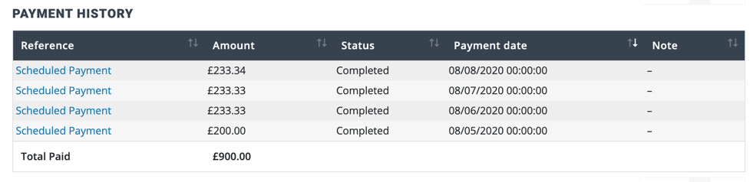
- Click on the payment reference to view details about the payment.
  - View the reason for an error
  - Download the receipt PDF.

PAYMENTS & ALLOCATIONS

Refunding Payments
To record a payment refund, for a payment that was taken offline i.e. in cash, by cheque or through the club’s PDQ machine. Following one of the steps mentioned in the previous section, locate the bill or payment to be refunded.
- Click on the payment reference to view the payment details.
- Click the refund button, shown below. This will record a refund against the bill and will initiate a refund receipt to be sent to the member. However, the payment of the refund will need to be completed offline.
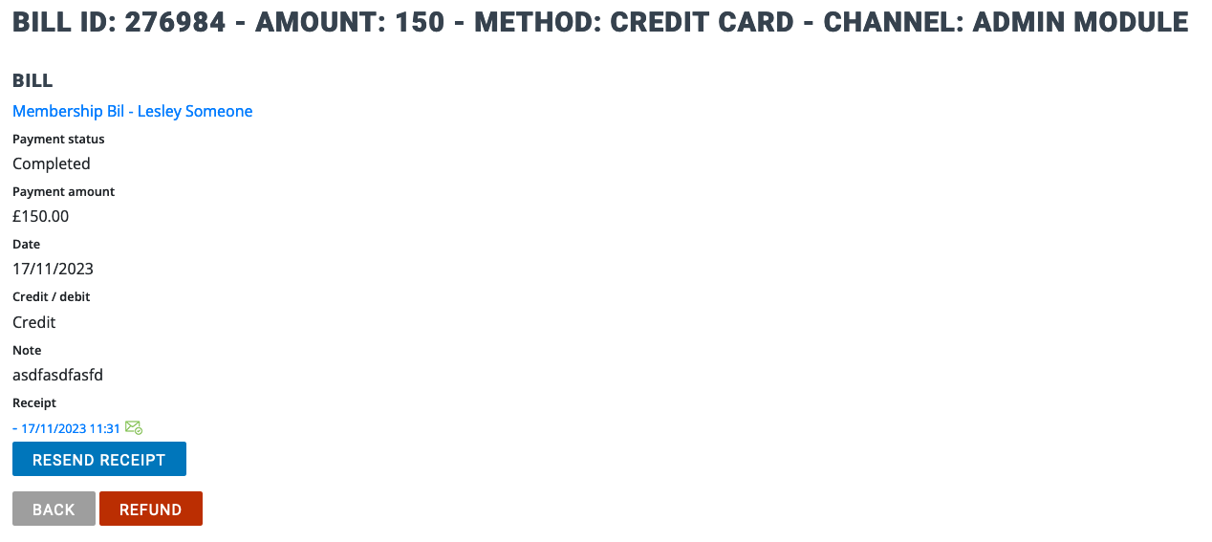
To record a payment refund for a payment that was taken online. Following one of the steps mentioned in the previous section, locate the bill or payment to be refunded.
- Click on the payment reference to view the payment details.
- Click the refund button, shown below.
- This will record a refund against the bill and will initiate the refund back to the member’s bank account. This records a refund against the bill and will initiate a refund receipt to be sent to the member.
- Note: Refunds may take up to 7 days to appear in the member’s account.
Note: Refunds for online payments will be reflected in your online payment reporting tool, shown later in the guide.

PAYMENTS & ALLOCATIONS

Cancelling future Scheduled Payments
When a member has signed up for a payment scheme and has scheduled payments assigned to their bill, it will be possible to cancel on or all of the remaining scheduled payments.
Following the steps mentioned in the previous section, locate the bill for the member. The Payment History will list all scheduled payments with a status of either Completed or Scheduled.
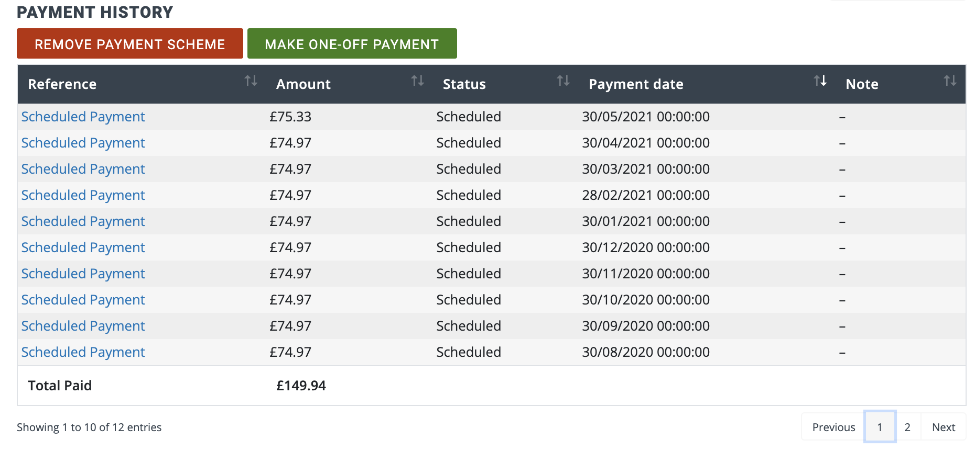
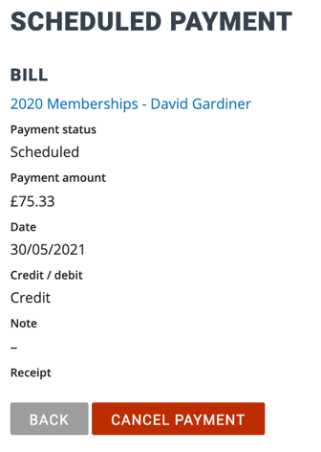
To cancel an individual scheduled payment:
- Click on the payment reference to view the payment details.
- Click the Cancel Payment button, shown here.

To cancel all future scheduled payments, click the Remove Payment Scheme button in the payment history on the Bill Details page.

ONLINE PAYMENTS REPORTING

Online Payments Reporting
As previously mentioned in this guide, the BRS Memberships module uses our online payments platform known simply as ‘Payments’ to handle online payments. The Payments platform is also used to handle online open competition payments, visitor green fees, and payment request emails.
To report on online payments made by members for their bills, follow these steps:
- Log in to BRS.
- Navigate to the Tools area.
- Scroll down to the grey coloured panel titled ‘BRS Payments’.
- Click on the Payouts tool.
- Click on the value in the Amount column.
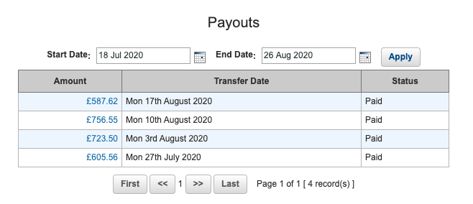
You will see a table with detailing the payments and fees included in this payout. Payments which have been made via the BRS Memberships system (and their corresponding fees) will be flagged as ‘Memberships’ in the Source column.
This data can be sorted by clicking on a column and can also be downloaded in spreadsheet (CSV) format or printed by using the respective buttons at the top of the page. Payouts are paid into your nominated bank account on a rolling, 7-day schedule each Monday.

REPORTING

Reporting Suite
To access the main suite of pre-built reports in the Memberships system, simply navigate to Memberships and select the Reports in the menu at the top of the page. You will see a list of Financial Reports and Member Reports.
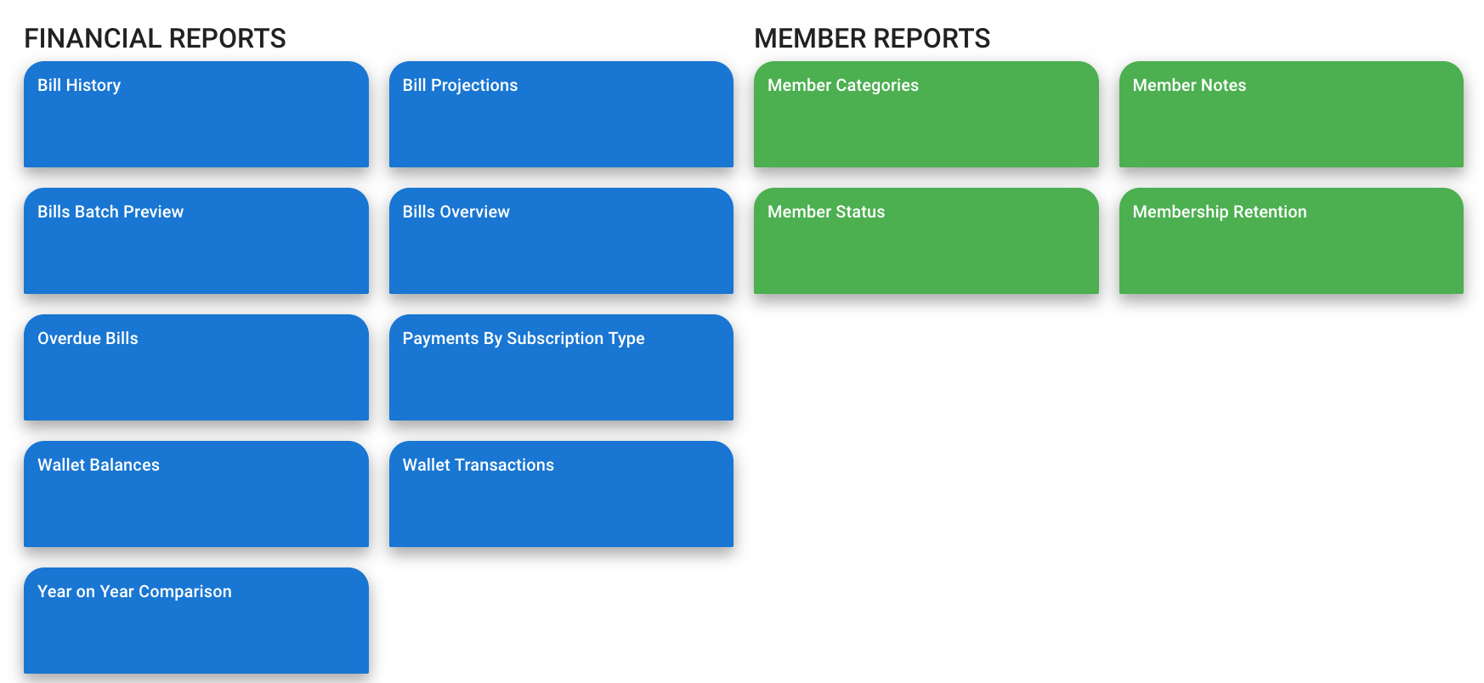
Most of the reports have additional relevant filters that will be applied when you select a value.
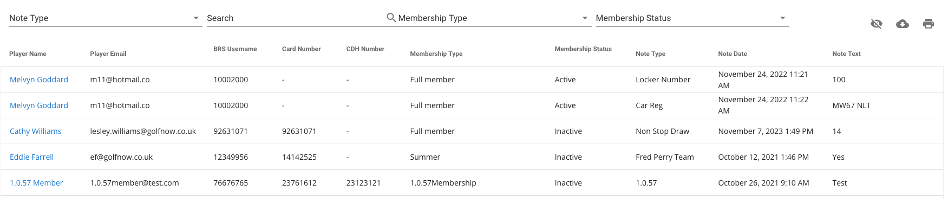
In each report you will see three icons towards the top right of the report results (). From left to right these are:
-  allows you to choose the columns to display or hide in the results
-  allows you to download the data to a CSV file. You will be asked if you want to download the filtered results or all results. The CSV file will be saved to your downloads folder.
-  allows you to printer the report results.

REPORTING

Reporting Suite, continued
Financial Reports
Report Name | Description
Bill History | Provides an audit trail of changes to individual bills or bill batches
Bill Projections | Provides a summary of expected revenue per month per bill or bill batch.  This is particularly useful for bills with scheduled payments as it gives you a projection of the revenue per month.
Bill Batch Preview | Provides a summary of bills/bill batches including payment information.  This report allows you to filter on specific bill batches, publish status, individual subscriptions (line items) and payment dates. Also, it provides a total panel for the filtered data.
Bills Overview | Provides a summary of bills/bill batches.  With this report you can filter on Due date (from and to), publish status, payment status and membership type (you can select multiple membership types). Also, it provides a total panel for the filtered data.
Overdue Bills | Displays a list of members’ bills which are past their due date.  With this report you can filter on Due date (from and to) and payment status.
Payments by Subscription Type | Provides a summary of payments against each subscription item, including VAT calculations. It displays the general ledger code (GL code) that you specify when you create the subscription.  With this report you can filter on one or more bill batches, tax rates, payment date range, payment type. You can choose to include custom line items and/or surcharge line items. Also, it provides a total panel for the filtered date.
Wallet Balances | Provides the balance in wallets as a today or a selected month end.  With this report you can filter on one or more wallets.
Wallet Transactions | Provides a list of all wallet transactions.  With this report you can filter on an individual wallet, a date range and a type of transaction (topup, purchase, refund etc).
Year on Year Comparison | Provides a summary of bills and payments compared to previous years.  With this report you can filter on a start/end date and select the number of years to compare.

REPORTING

Reporting Suite, continued
Member Reports
Report Name | Description
Member Categories | Provides a list of membership types and the number of members in each category.  From this report you can click through to view the membership type and the individual members within.
Member Notes | Provides a list of notes associated with each member.  With this report you can filter on an individual note type, search for specific text, filter on an individual membership type and/or membership status.
Member Status | Provides a list of membership statuses and the number of members in each category.
Membership Retention | Provides a monthly report of member gains and losses.

REPORTING

Data Table Reporting
The four main areas of BRS Memberships are the Members, Membership Types, Subscriptions and Billing/Payments sections. When navigating to these areas of BRS Memberships you will see a data table containing a list of, for example, all the subscriptions which have been created.
The three buttons at the top of each data table (), allow you to do the following:
-  allows you to choose the columns to display or hide in the results.
-  allows you to download the data to a CSV file. You will be asked if you want to download the filtered results or all results. The CSV file will be saved to your downloads folder.
-  allows you to printer the report results.

BRS MEMBERSHIPS – MEMBER FUNCTIONALITY

New Functionality for Members – Browser Version
Your members will be able to access BRS Memberships through their existing member login. A new menu option, highlighted below, will appear. Clicking on this Membership item in the menu displays their Membership Dashboard, giving them an overview of bills.
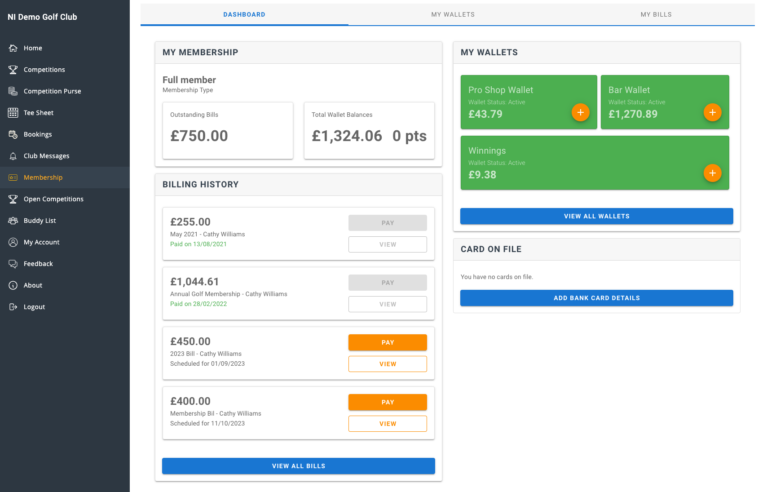
The ‘My Wallets’ area contains a list of wallets which have been assigned to a member, as well as the available balances of these wallets. The member can search through their previous wallet transactions using the filters provided.
‘My Bills’ allows a member to manage their bills and add or update a bank card held on file. A total outstanding balance displays at the top of this page, and a list of the member’s bills is available underneath with options to View or Pay a bill.
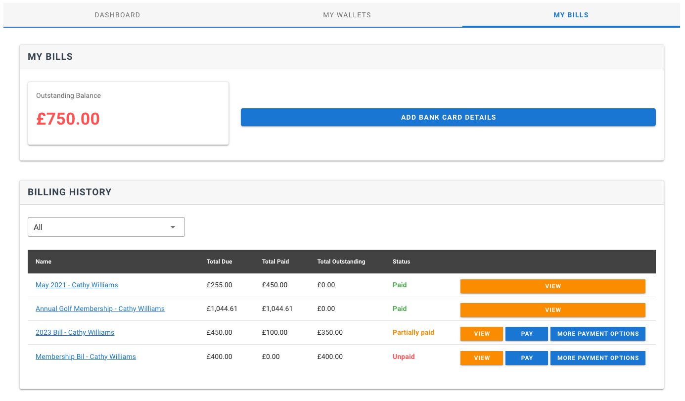

BRS MEMBERSHIPS – MEMBER FUNCTIONALITY

New Functionality for Members – Members Booking App
Members can access their Membership information through BRS Members Booking App. They can manage wallets, bills and their payment card information.

